FEATURES OF THE PROJECT

# ANDROID APP – USER END:

1. Automatic GPS check using the **GoogleClient API**.
2. **Turning on the GPS** automatically just the way Google Maps and OLA does it.

Sample at : <https://github.com/VarshaJambunathan/FirebaseOperations/blob/master/app/src/main/java/com/example/varsha/databasequeries/MainActivity.java>

1. Accepting the Name and Phone number of the user.
2. Automatically pinging the Latitude and Longitude of the user as soon as user clicks on **HELP**.

Sample at : <https://github.com/varunsinha/Hack108IIT/blob/master/app/src/main/java/com/varunsinha/jam/MapsActivity.java>

(You may find different repositories for this app because we have split them into modules and are currently integrating them.)

## Screenshots:

# DATABASE :

1. We have used **Firebase** for its quick and easy addition and deletion advantages.
2. A new record is created each time a HELP button is clicked.
3. This record contains **name, phone number latitude and longitude** of the user sending it.

## Screenshot:

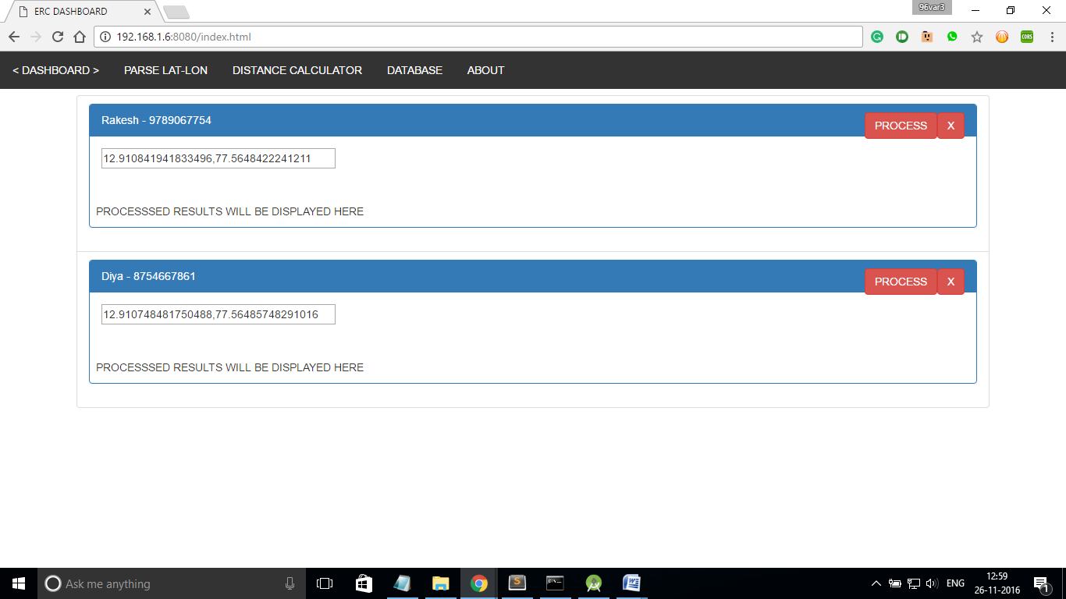

# WEB APP aka ERC DASHBOARD:

1. Dashboard facilitating the dynamic update of any new location in Firebase.